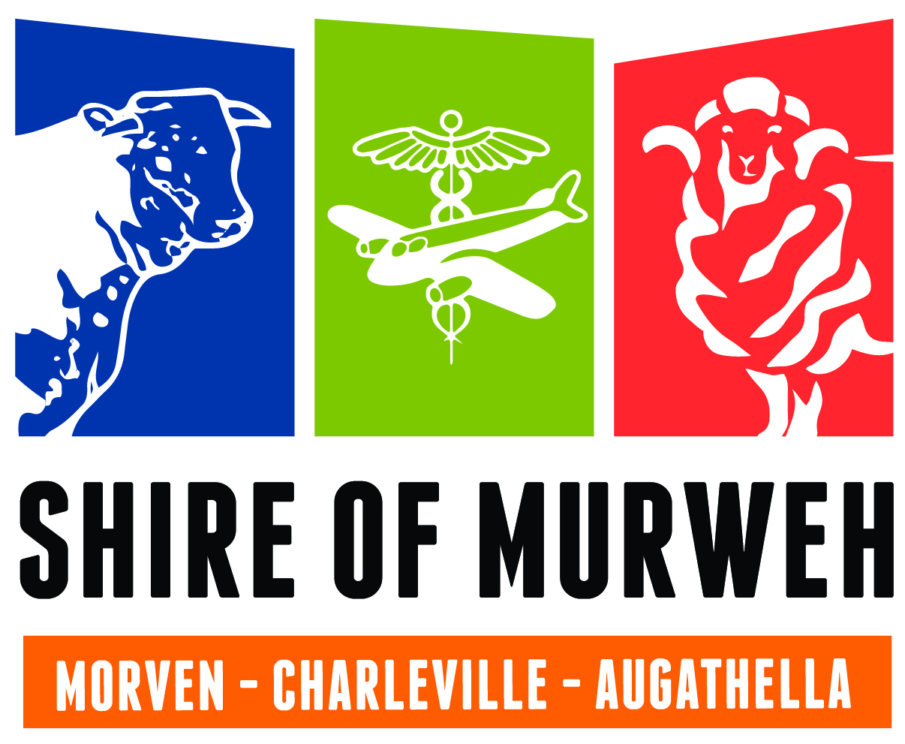 | Murweh Shire  Community Assistance Program  For activities up to 31 December 2024
Guidelines and Application Form

Twice a year council calls for applications from Clubs/Organisations/Individuals requiring Council Assistance in the coming financial year.

Organisations are to note that Council, when providing assistance will not provide direct cash contributions but will enable the provision of in-kind support only (no direct cash donations).

“IN-KIND” support generally means a provision of goods or service, a waiver of fees etc and will not be a direct cash contribution. Assistance is divided into Waiver of fees/In-Kind Assistance from Council and Other.

The following local organisations will be eligible for assistance under this policy: -
- Charities
- Not for Profit or Religious Organisations
- Sporting or Hobby Groups / Bodies

Council shall determine what “in-kind” assistance shall be provided to each applicant when framing its’ budget for the coming year.

In determining the level of assistance required, Council shall: -
- Establish the level of funding available in terms of its’ coming budget requirements;
- Apportion such funding across each application eligible for funding.

Council shall have sole discretion in determining the type and level of support to be provided to each applicant.

It shall not be the policy of the Council to prioritise the needs of one applicant against another in determining the level of support, except that the applicant must be an eligible applicant in terms of the above eligibility criteria.

Notification of the assistance to be provided by Council shall be undertaken as soon as practicable after Councils’ meeting.

When successful, the applicant MUST contact Council to organise assistance and quote the job number provided in letter.

Applicants requiring assistance under this policy must fill in the information requested in the application form and complete all sections necessary marked with an *

______________________________________________________________________________

Applications received after the advertised closing date may not be considered for assistance by Council in the coming financial year.

Please keep this page for your information (and a copy of your application)
Murweh Shire Council
Assistance for the half year ending 31 December 2024

Application Form
_____________________________________________________________

Applicant Details *
Organisation Name:
Email Contact:
Postal Address:
Town: |  | Postcode:
ABN:
Incorporation:
Person Making this Application on behalf of organisation/club *
Name:
Position in Club:
Phone:
Email:
Club/Organisation Details *
President:
Secretary:
Treasurer:
Other Committee:
Role of the Organisation/Club in Community *
Aims/Benefits to the Community of the Assistance applied for *

Application Type *
What is the Assistance for?
Waiver of Hire Fees | □ if yes, please complete “Waiver of Hire Fees” section
Ïn-Kind Assistance | □ if yes, please complete “In-Kind Assistance” section
Other | □ if yes, please complete “Other Assistance” section
 | Complete ALL applicable sections
Waiver of Hire Fees
$ Value (office use only)
Event Location (Which Council Facility)
Date Facility Required |  | Start date: / /  (please note only activities up to 31 December will be considered)
 |  | End Date: / /
If required more than once, please detail:
e.g. for a period of 3 months from 1/7/17 each Wednesday from 6-7pm
Any other relevant information:

In-Kind Assistance
Please Provide details of the assistance requested from Council (attach additional if required)
Description (e.g. water truck, mow field etc) |  |  | Date Required | Location | $ Value  (office use only)
Other Assistance
Please detail other assistance you are requesting (please provide $ amount):

Club/Organisation Contribution: (please detail $ and other) *
Attached any additional Information (if required) [NO more than 2 A4 pages]

Please make sure ALL SECTIONS of the application have been completed

Agreement

I confirm that:

- The details in this application and any attachments are lawfully true and correct; and
- I have been legally authorised to make this application by the governing body of the organisation for which this application is being made; and
- The organisation named in this application accepts all legal and financial responsibility associated with this application and any funds granted should this application be successful.

Dated and signed at this day of 2024

Signature of Person making Application: _________________________________________________

Name (please print clearly)___________________________________________________

